TOGAF® Standard – Architecture Definition
Version 1.0
July 2026
Barangay San Antonio Health Department Enterprise Architecture
Barangay San Antonio Health Center, Pasig City
Document Version History
Version Number | Version Date | Revised By | Description | Filename
1.0 | October 22, 2026 | UA&P Solution Architecture team | First issue, based on interviews (October 2–21, 2026) and verification answers (October 22, 2026) | A5 - Architecture Definition.docx

Contents
1. Purpose of this Document 5
1.1 Output and Input 5
2. Architecture Definition 6
2.1 Scope 6
2.2 Goals, Objectives, and Constraints 6
2.2.1 Goals 6
2.2.2 Objectives 6
2.2.3 Constraints 6
2.3 Architecture Principles 7
2.4 Baseline Architecture 7
2.5 Architecture Models (For Each State to be Modeled) 8
2.5.1 Business Architecture Models 9
2.5.2 Data Architecture Models 13
2.5.3 Application Architecture Models 14
2.5.4 Technology Architecture Models 15
3. Rationale and Justification for Architectural Approach 16
3.1 Rationale 16
3.2 Approach 16
4. Mapping to Architecture Repository 17
4.1 Mapping to Architecture Landscape 17
4.2 Mapping to Reference Models 17
4.3 Mapping to Standards 17
4.4 Re-Use Assessment 17
5. Gap Analysis 18
6. Resolve Impact Across the Architecture Landscape 19
6.1 Impact on Pre-Existing Architectures 19
6.2 Recent Changes Impacting the Business Architecture 19
6.3 Opportunities 19
6.4 Impact on Other Projects 19
7. Transition Architecture 20
7.1 Definition of Transition States 20
7.2 Business Architecture for Each Transition State 20
7.3 Data Architecture for Each Transition State 21
7.4 Application Architecture for Each Transition State 21
7.5 Technology Architecture for Each Transition State 21
A Abbreviations 22
Tracking Information
Project Name | Barangay San Antonio Health Department Enterprise Architecture
Prepared By | Rome Victor Mag-iba Sendin (Group Leader); Samuel Anthonius Badillo; Wilson Halim; Kevin Enrico Ang | Document Version No. | 1.0
Title | Architecture Definition | Document Version Date | October 22, 2026
Reviewed By | Dr. Glynnis Lynn U. Bonilla, Medical Officer IV (Executive Sponsor) | Review Date | October 23, 2026
Distribution List
From | Date | Phone/Email
Rome Victor Mag-iba Sendin, Group Leader, UA&P Solution Architecture | October 22, 2026 | romevictor.sendin@uap.asia / 09456315746

To | Action* | Due Date | Phone/Email
Dr. Glynnis Lynn U. Bonilla, Medical Officer IV | Approve | October 23, 2026 | bsahealthcenter@gmail.com
Hon. Thomas Raymond U. Lising, Punong Barangay | Review | October 23, 2026 | bsahealthcenter@gmail.com
Hon. Rachel Marie S. Rustia-Olarte, Co-Chair, Committee on Health & Nutrition | Review | October 23, 2026 | bsahealthcenter@gmail.com
Mr. Joel Pira, Instructor, Solution Architecture (UA&P) | Review | October 23, 2026 | joel.pira@uap.asia
* Action Types: Approve, Review, Inform, File, Action Required, Attend Meeting, Other (please specify)

Purpose of this Document
The Architecture Definition Document is the deliverable container for the core architectural artifacts created during a project and for important related information. The Architecture Definition Document spans all architecture domains (Business, Data, Application, and Technology) and also examines all relevant states of the architecture (Baseline, Transition, and Target).
A Transition Architecture shows the enterprise at an architecturally significant state between the Baseline and Target Architectures. Transition Architectures are used to describe transitional Target Architectures necessary for effective realization of the Target Architecture.
The Architecture Definition Document is a companion to the Architecture Requirements Specification, with a complementary objective:
- The Architecture Definition Document provides a qualitative view of the solution and aims to communicate the intent of the architects
- The Architecture Requirements Specification provides a quantitative view of the solution, stating measurable criteria that must be met during the implementation of the architecture

Output and Input
The TOGAF® Content Framework (see 4. Architecture Deliverables) identifies deliverables that are produced as outputs from executing the Architecture Development Method (ADM) cycle and potentially consumed as inputs at other points in the ADM.
This deliverable is produced, updated, and consumed by the ADM Phases:
Deliverable | Output from… | Input to…
Architecture Definition | A, B, C, D, E, F | B, C, D, E, F, G, H

Architecture Definition

Scope
Barangay San Antonio Health Center is the primary-care facility of Barangay San Antonio, Pasig City, operating under the Pasig City Health Department (CHD). It serves a barangay of about 13,000 residents (more than 17,000 including transients), 798 children under five, about 63 condominiums, and relocated San Antonio families in Tanay, Rizal (relocated around 2018). Its 16 on-site staff handled 657 patient visits last month: 360 consultations (Monday, Tuesday and Friday, 8–11 AM) and 297 maintenance-medicine pickups (Monday, Wednesday and Friday afternoons).
In scope | Out of scope
All health department operations (care, dental, nutrition, medicine logistics, records, reporting, outreach, referrals, staffing, budgeting, IT, facility); barangay-funded decisions; recommendations to the City | Building software; changing City or national systems; City-level HR, procurement and policy; patient-level data

Goals, Objectives, and Constraints

Goals
- G1 Enter data once.
- G2 Keep maintenance medicines in stock.
- G3 Faster records and reports.
- G4 Official, secure work tools.
- G5 Better patient flow and reach.

Objectives
Objective (proposed) | Baseline | Target | By
Prescription entries per consultation | Up to 3 | 1 (City dependent) | Dec 2027
Months with maintenance-medicine stock-outs | 3 (2026) | 0 | 2027
Old-patient record retrieval | 2–10 minutes | < 1 minute | Jun 2027
Reports compiled after hours | Common | None | Jun 2027
Work files on personal accounts | Most | None | Dec 2026
Frontline staff with computer access | 0 of 7 | All (shared) | Jun 2027

Constraints
- City EMR and other City/national systems cannot be changed by the center.
- Minor process or system changes need City Health Officer approval; major ones need the City Mayor.
- Permanent and job-order staff are City employees; BHWs are barangay contractual; hiring and promotion follow each employer.
- Medicines and dental supplies come through City procurement; deliveries are often partial.
- Barangay funding follows the annual budget; 2027 proposals are due November 2026.
- No rollouts during OPT Plus and MR-SIA (January–March) or month-end reporting.
- Data Privacy Act (RA 10173) and DOH 7-year retention apply.

Architecture Principles
The three principles below were established in the Preliminary Phase.
Name | One Patient, One Record
Statement | Every patient has exactly one authoritative record, and filing rules work no matter which staff member files.
Rationale | Filing is a shared team task with no on-site records clerk (the Records Officer is at City level), so charts are misfiled or duplicated; a misfiled chart takes up to 10 minutes to find versus 2–3 minutes when filed correctly.
Implications | All staff use one index (the record number on the ITR, linked to the EMR). Time is set aside to merge duplicates and archive inactive charts. First-visit registration takes slightly longer.

Name | Use the City Record, Don't Rebuild It
Statement | The City EMR is the system of record; any center-level tool feeds it and never creates a separate copy of patient data.
Rationale | The EMR is shared with other Pasig health centers and hospitals, returns a record in about 5 seconds when the internet is stable, and only the City and its vendor can change it.
Implications | The center gives up building its own patient database. Any offline fallback must sync back to the EMR. Integration needs are sent to the City Health Department as requests.

Name | Report Once, Count Many Times
Statement | Each service is recorded once, at the point of care, and every program report is derived from that entry.
Rationale | One midwife consolidates 7 monthly program reports in a one-day window (30th to 1st) before CHD review ahead of the first Wednesday, often finishing in the evening.
Implications | Encounters and field visits carry standard tally fields. Aides and BHWs enter tallies the same day. Month-end retyping and redundant forms are reduced.

Baseline Architecture
Domain | Baseline summary | Key evidence
Business | Cooperative team with a buddy system; reports never late; processes depend on paper, manual tallies and a few people (one doctor, nurse, midwife and encoder) | 657 visits last month; 7 monthly program reports; 20–25 trainings a year
Data | Patient data on ITR and chart, typed into the EMR, retyped into PhilHealth YAKAP; tallies retyped into personal Google Sheets; stock tracked by hand; consent at every visit | ~8,000 charts; misfiled charts up to 10 minutes; prescriptions entered up to 3 times
Application | City EMR (eMed, outsourced ~2023), dental eMED, PhilHealth HCI/YAKAP, LMIS, ITIS, NNC e-OPT; Google Drive, Messenger, Viber on personal accounts | 30+ work group chats; 15 GB personal storage
Technology | 4 City laptops (10+ years old), 2 barangay desktops, 1 barangay laptop, BNS laptop, 4 printers; PLDT line (~₱3,000 a month) | ~5 outages a month; City approves all software

Architecture Models (For Each State to be Modeled)
Figure 1 shows the target state across all four domains. The baseline (current) state of each domain follows in Sections 2.5.1 to 2.5.4, and the transition states are in Section 7. Detailed catalogs and matrices are in the Architecture Deliverables for Phases B, C and D.
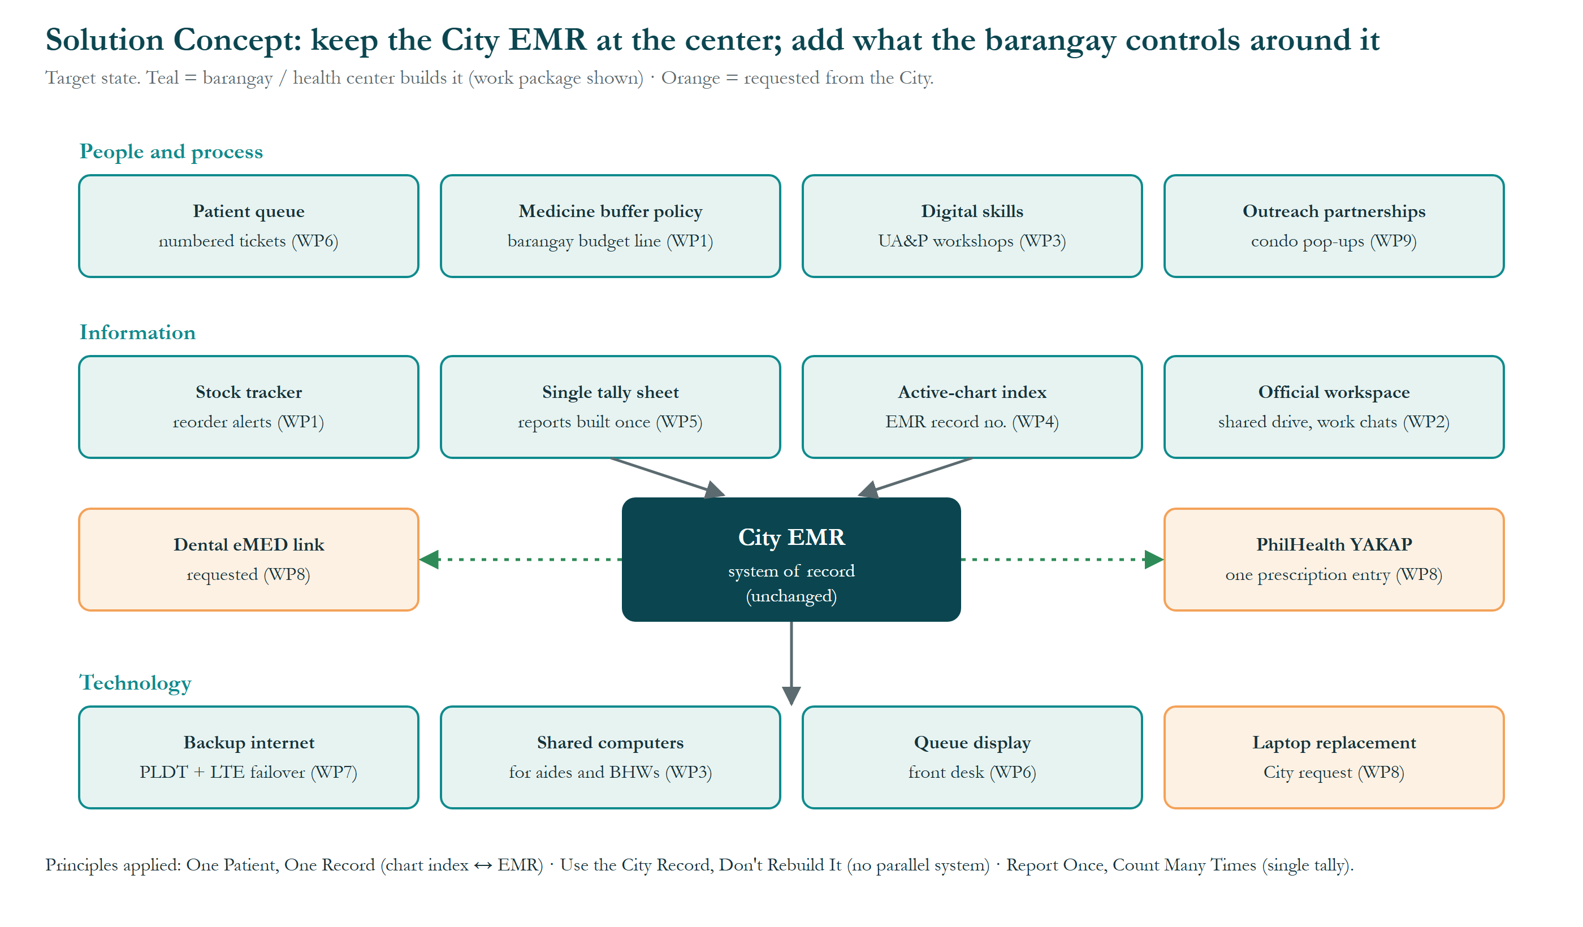
Figure 1. Solution Concept (target state, all domains).
What this shows: the planned future set-up. The City's patient record system (EMR) stays in the middle, unchanged. Around it are the improvements the barangay and health center can make themselves (teal) and the changes only the City can make (orange), grouped into people and process, information, and technology. Why it matters: the center improves without building a second patient system.

Business Architecture Models
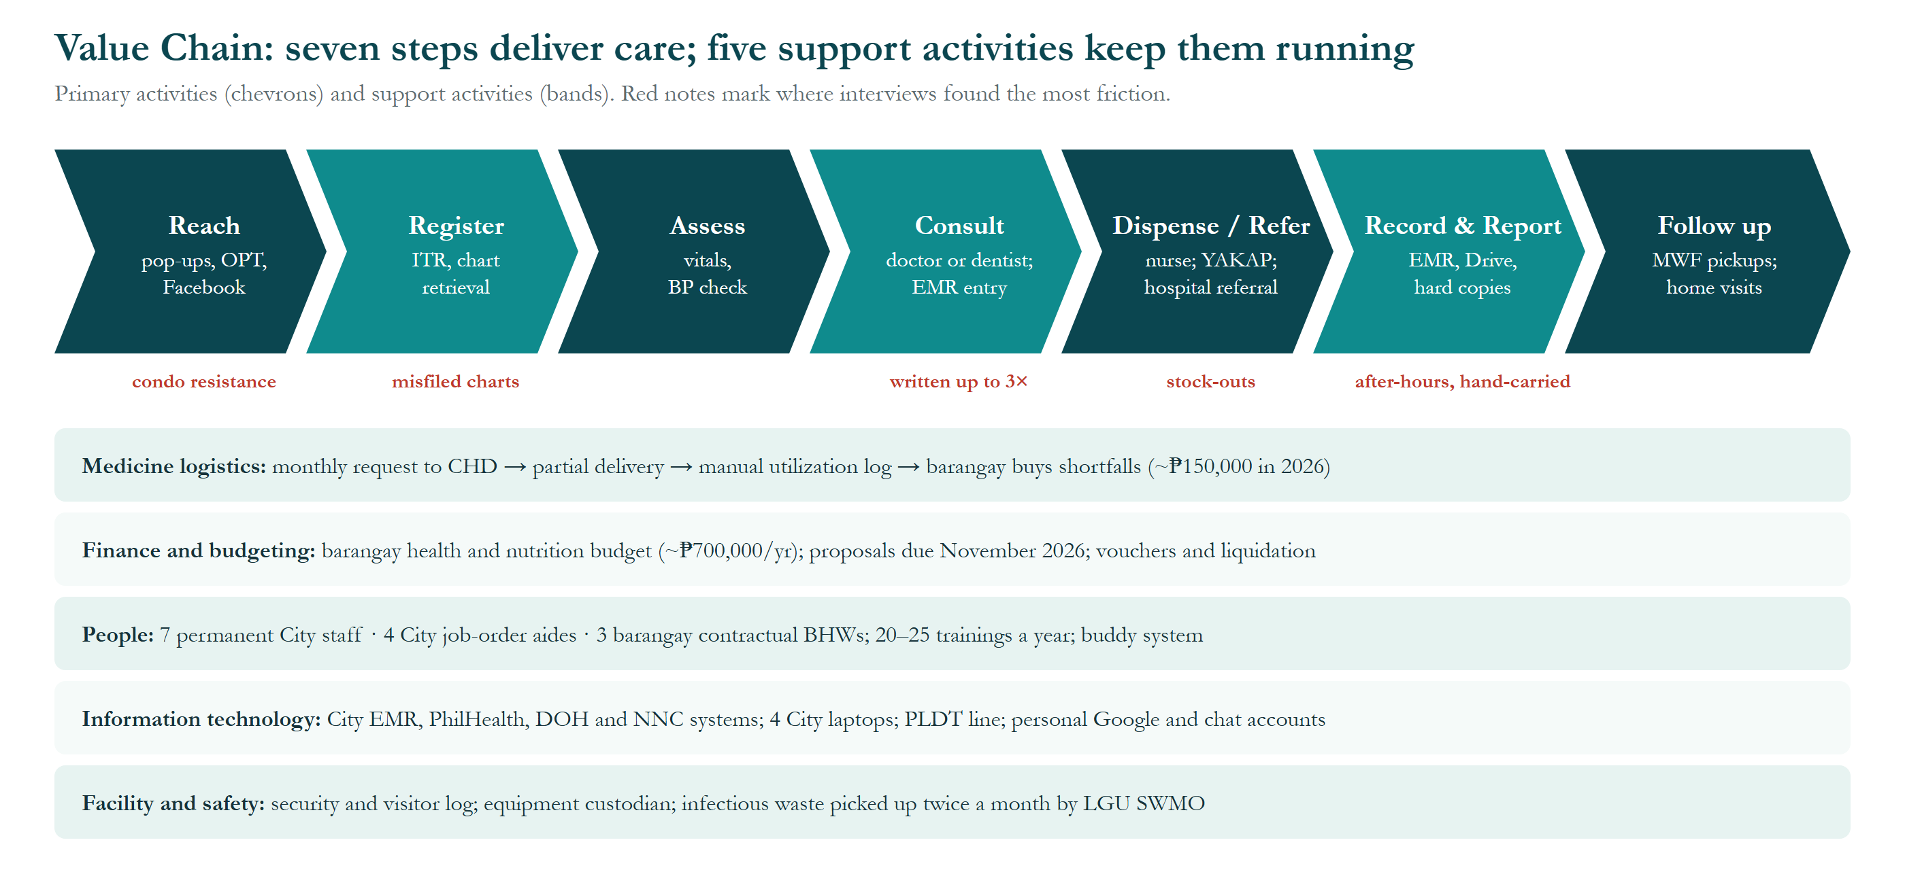
Figure 2. Value Chain.
What this shows: the seven steps a patient's care goes through, from reaching people in the community to follow-up, plus the five background activities (medicines, budget, people, IT, facility) that keep those steps running. Red notes mark where staff said things go wrong most. Why it matters: the biggest delays are at registration (misfiled charts), prescriptions (written up to three times), medicines (stock-outs) and reporting (after-hours work).
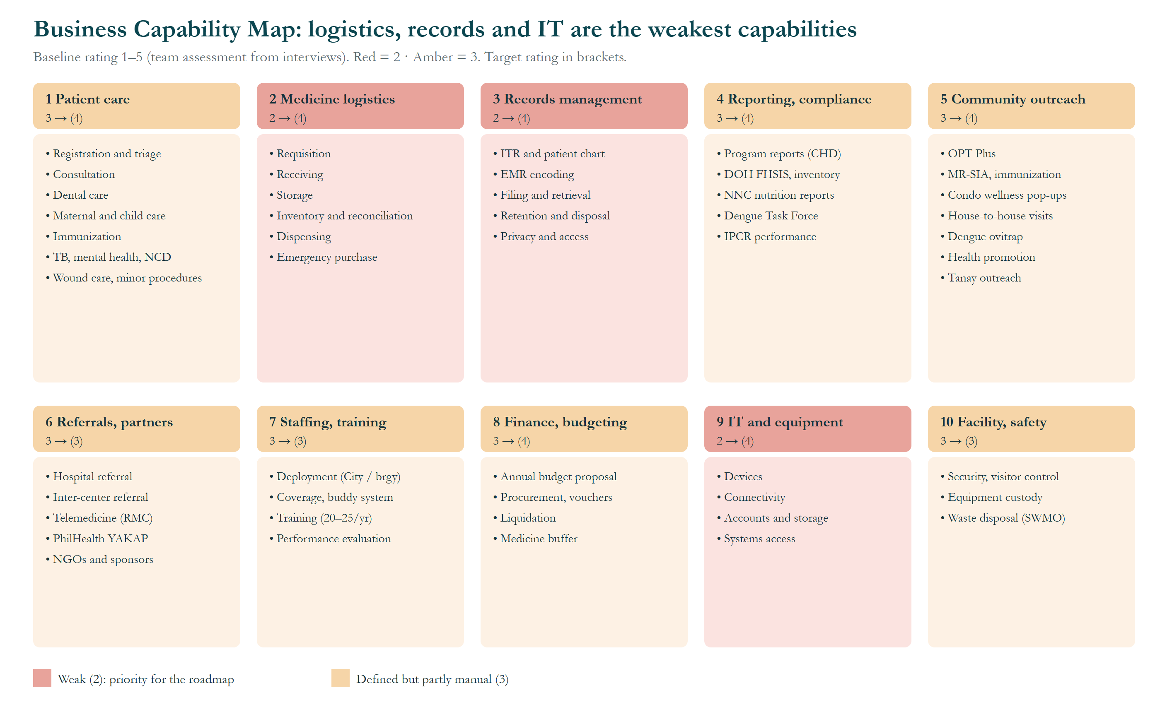
Figure 3. Business Capability Map.
What this shows: the ten main things the health department must be able to do, each rated from 1 (weak) to 5 (excellent) based on the interviews. Red boxes (rated 2) are the weakest: medicine logistics, records management, and IT and equipment. The number in brackets is the target. Why it matters: the roadmap fixes the red boxes first.
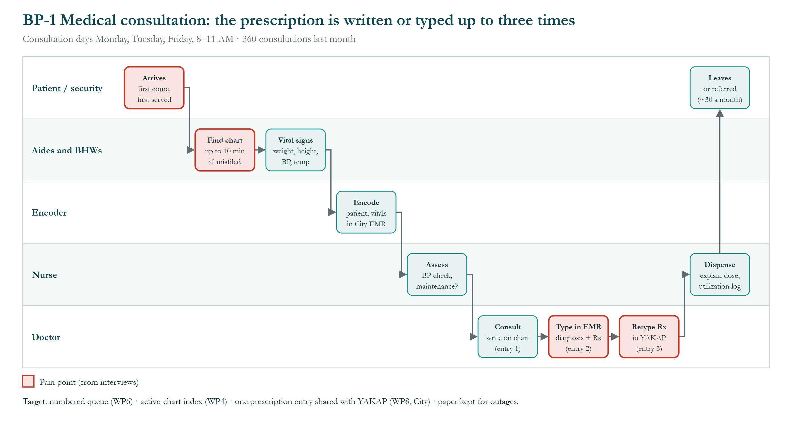
Figure 4. Process flow BP-1 Medical consultation.
What this shows: a consultation, step by step, with one row for each person or group involved. Red marks the problem spots: patients are served first come, first served; a misfiled chart can take up to 10 minutes to find; and the doctor's prescription is written on the chart, typed into the EMR, then typed again into PhilHealth YAKAP. Why it matters: fixing these saves time for both patients and staff.
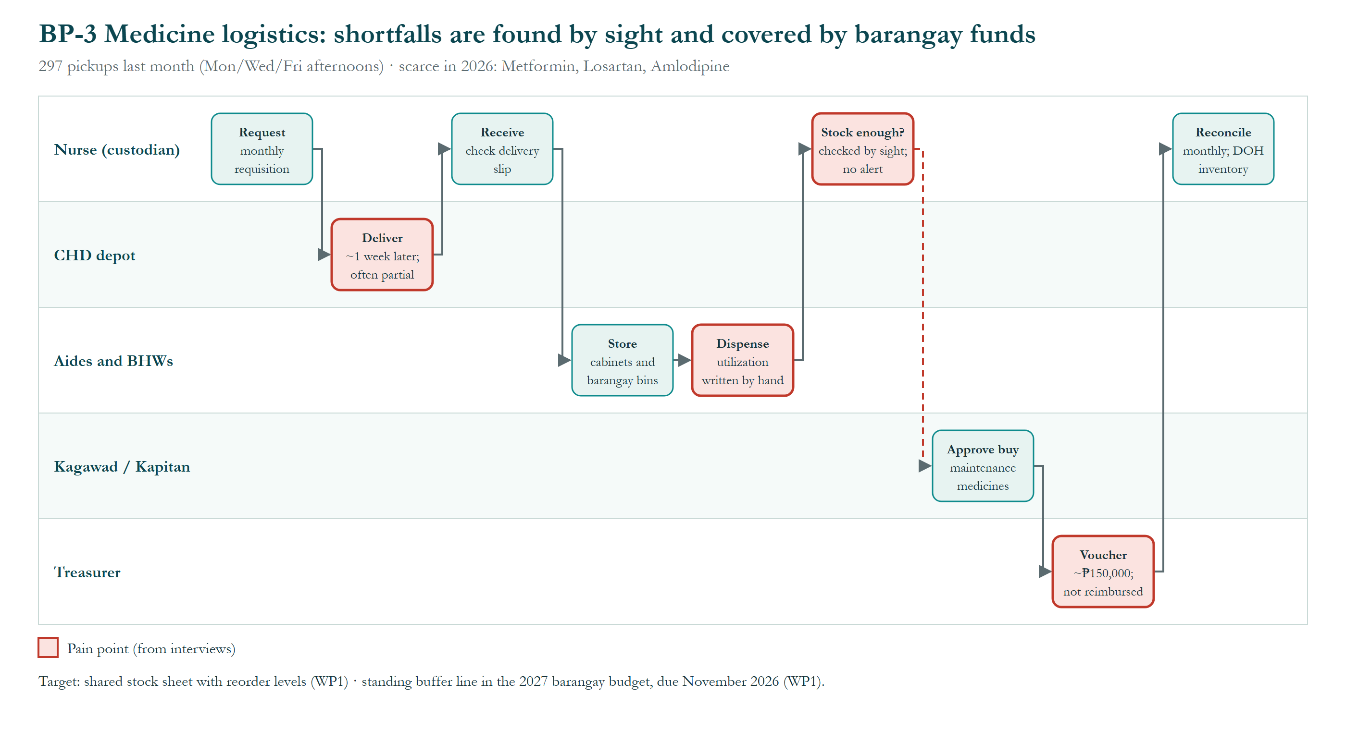
Figure 5. Process flow BP-3 Medicine logistics.
What this shows: how maintenance medicines travel from the City's supply to the patient. The center orders monthly, deliveries are often incomplete, stock is checked by eye, and when medicines run short the barangay buys them with its own money (about ₱150,000 in 2026, not paid back). Why it matters: a simple stock sheet and a planned budget line would warn staff before medicines run out.
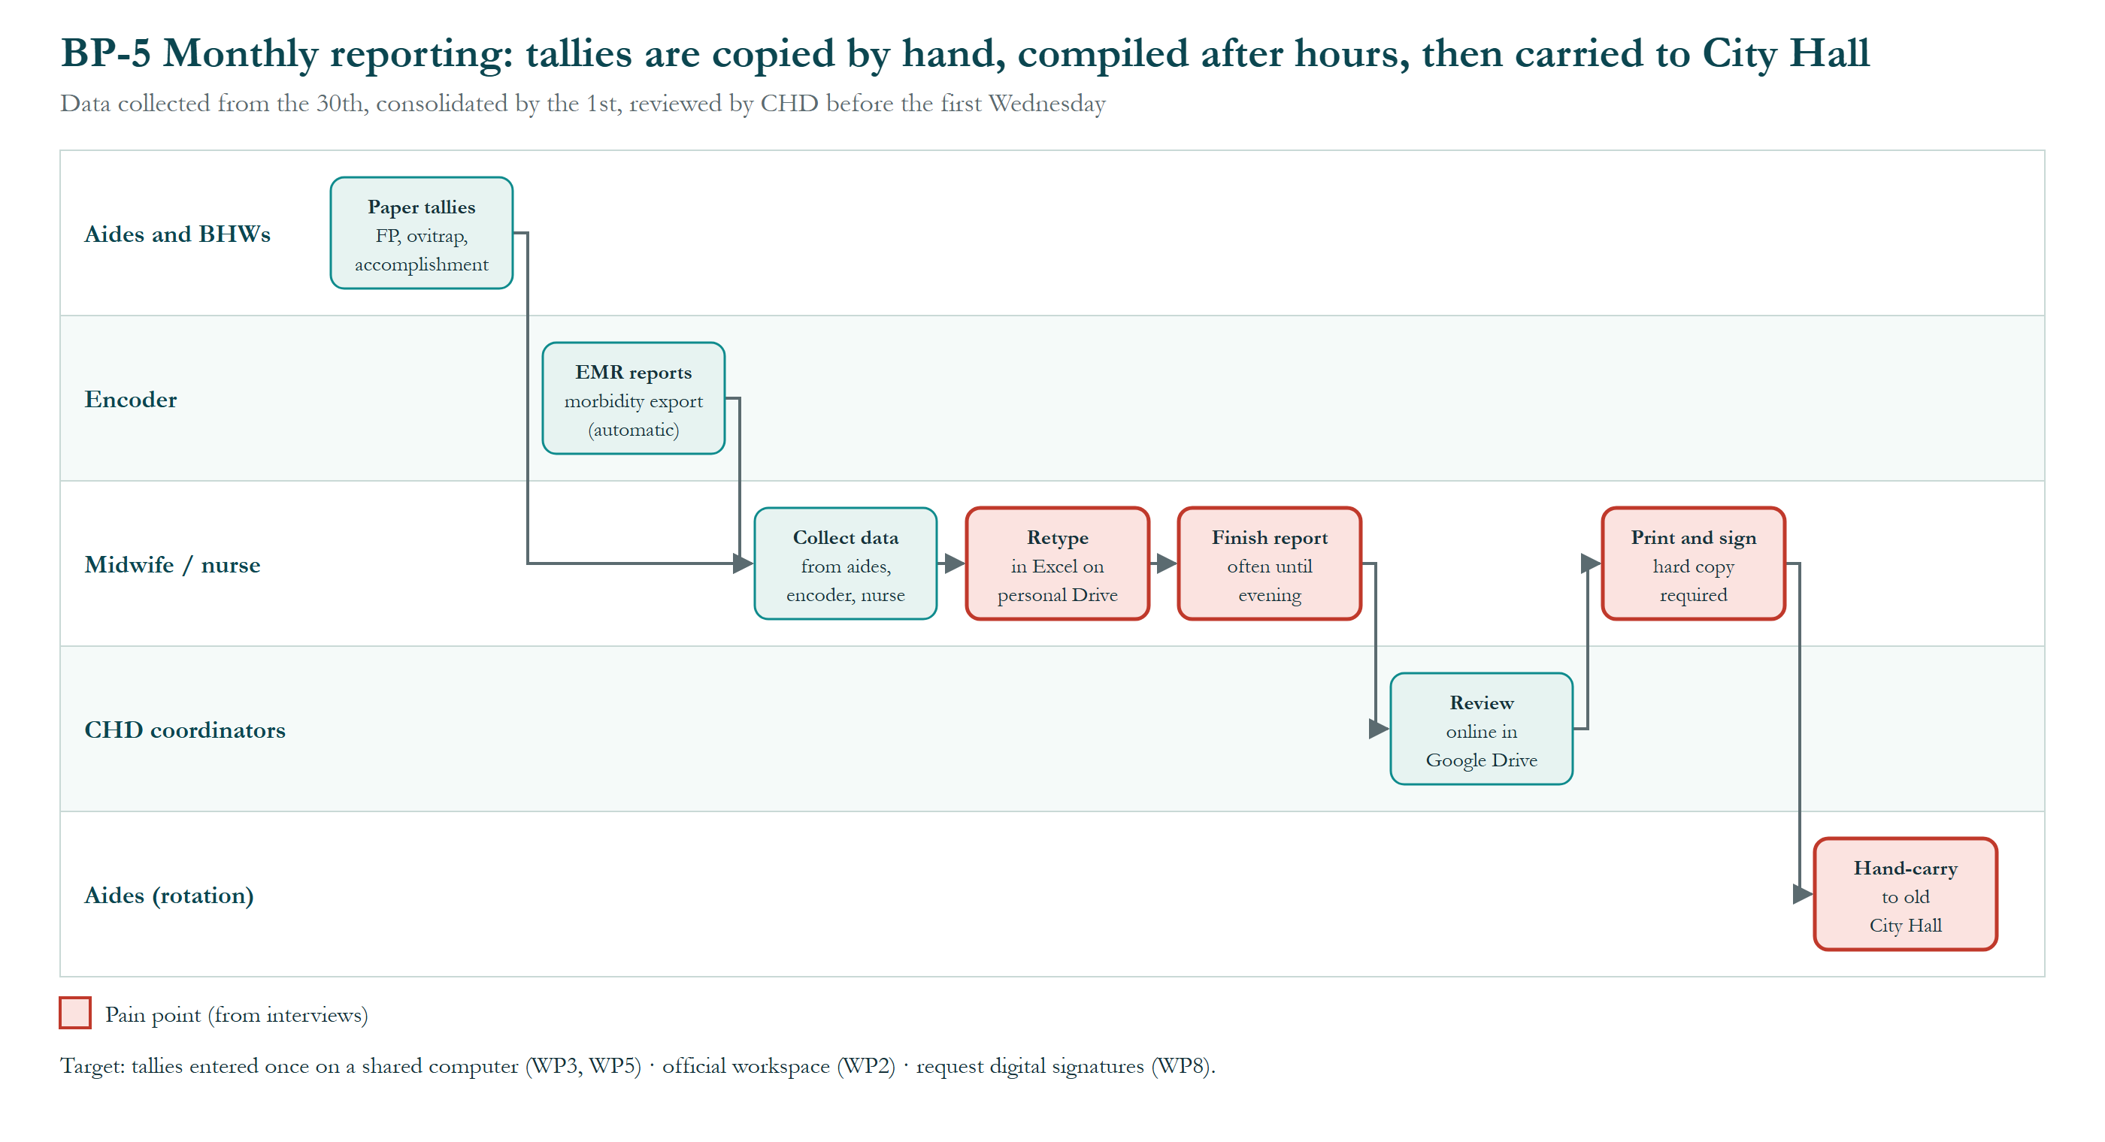
Figure 6. Process flow BP-5 Monthly reporting.
What this shows: how the monthly program reports are made. Paper tallies from the aides and BHWs are typed again into Excel on personal Google Drive accounts, often finished in the evening, then printed, signed and carried by hand to the old City Hall. Why it matters: entering each tally once on a shared computer would cut the copying and the late nights.

Data Architecture Models
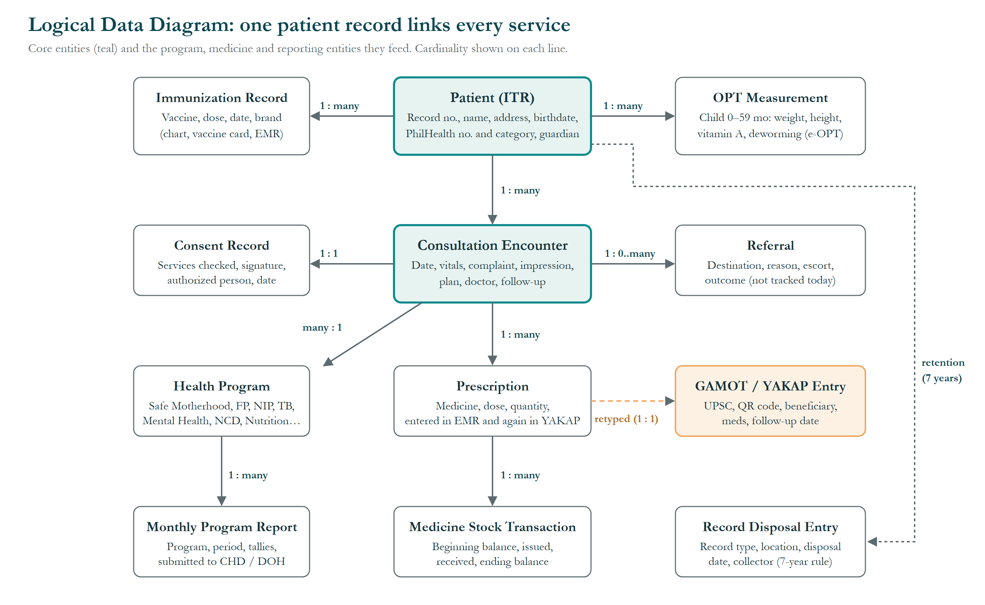
Figure 7. Logical Data Diagram.
What this shows: the main kinds of information the center keeps and how they connect. Everything links back to one patient record (the ITR): consultations, consent, prescriptions, referrals and immunizations. The labels on the lines show how many of one item relate to another (for example, one patient has many consultations). Why it matters: the whole system depends on that one patient record being clean and complete.
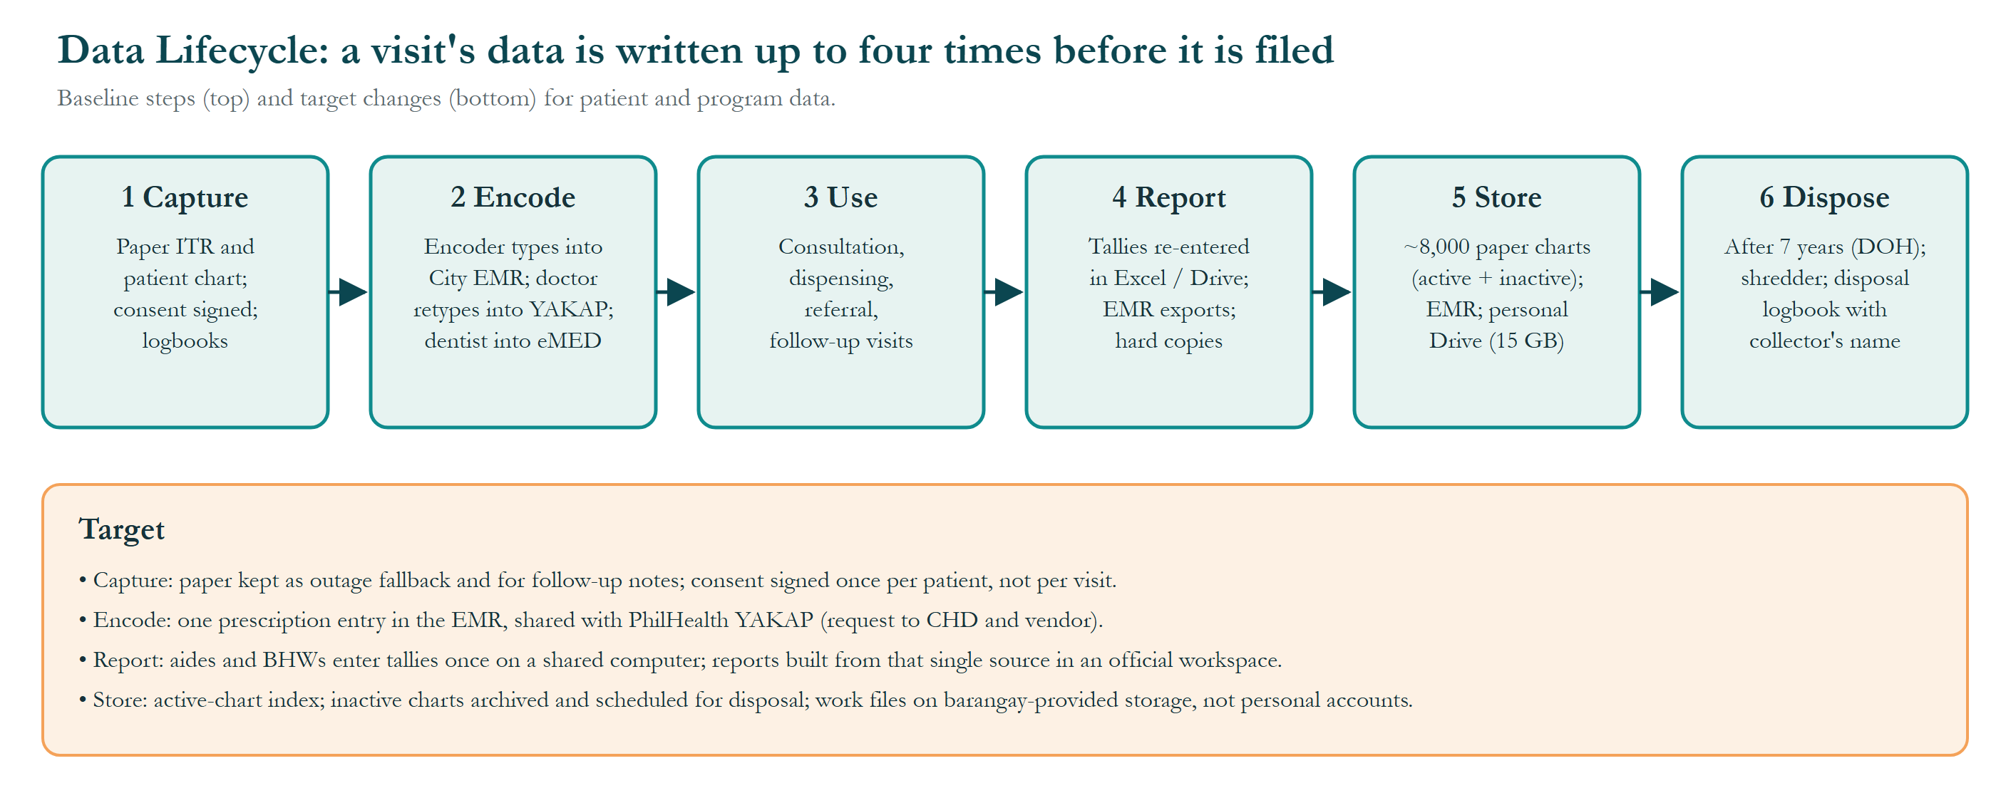
Figure 8. Data Lifecycle.
What this shows: the life of a visit's information in six stages, from writing it on paper to destroying it after seven years. Today the same information can be written up to four times along the way. The lower part lists the planned change for each stage. Why it matters: fewer copies mean fewer mistakes and less work.

Application Architecture Models
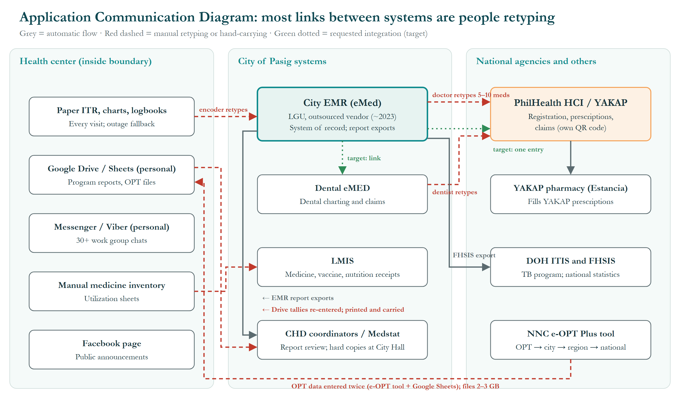
Figure 9. Application Communication Diagram.
What this shows: the computer systems the center uses and how information moves between them. Grey lines are automatic transfers; red dashed lines are places where a person must retype or hand-carry information; green dotted lines are links being requested from the City. Why it matters: most links are red, meaning staff are doing the systems' work by hand.

Technology Architecture Models
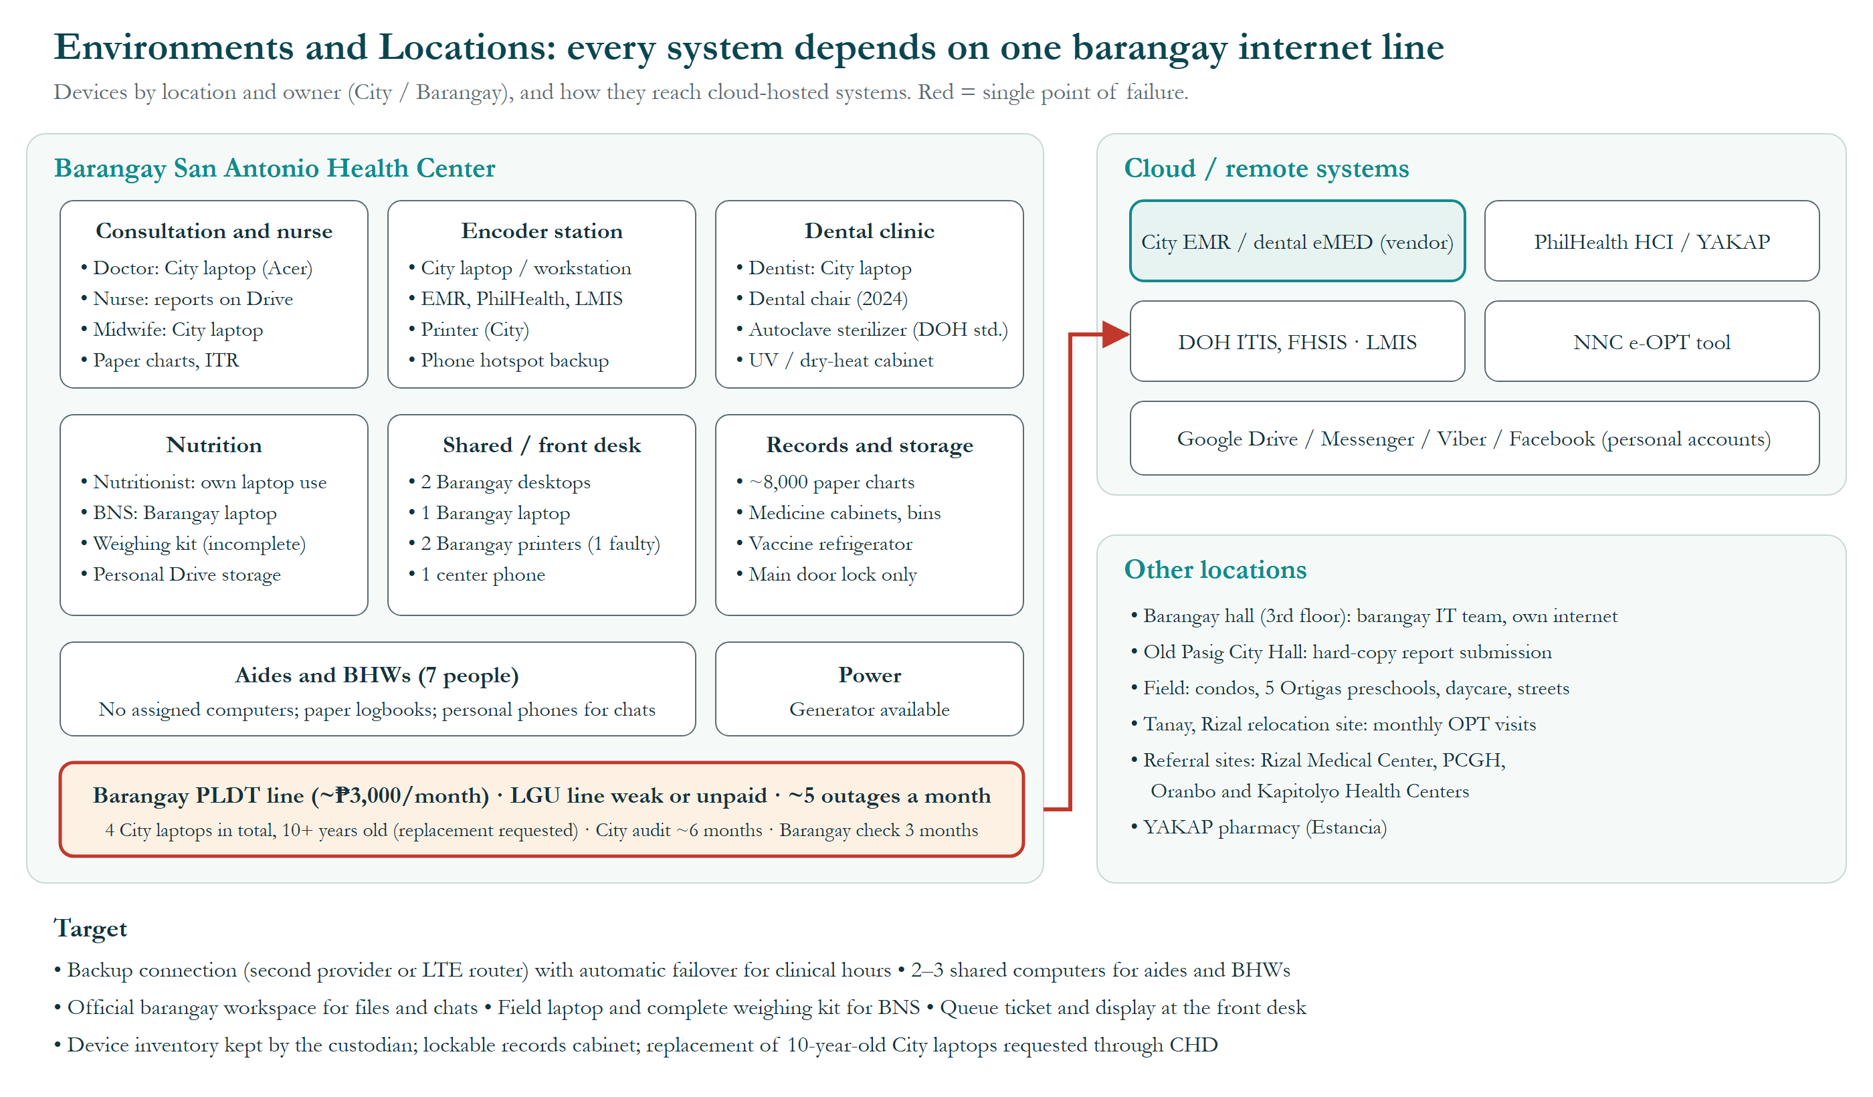
Figure 10. Environments and Locations Diagram.
What this shows: the computers and equipment in each part of the health center, who owns them (City or barangay), and how they connect to online systems. Every online system depends on one barangay internet line, which goes down about five times a month. Why it matters: when that line fails, EMR and PhilHealth work stops, so a backup connection is needed.

Rationale and Justification for Architectural Approach

Rationale
- The center does not own its core systems, so the target improves what the barangay and center control and documents a case for City-level changes rather than proposing a new system.
- Every recommendation traces to a named interviewee's problem and to one of the three principles.
- Low-cost, familiar tools fit staff skills, the barangay budget and City approval rules.
- Sequencing around OPT Plus and month-end reporting protects patient care.

Approach
- TOGAF 10 ADM, tailored in the Preliminary Phase (34-entity metamodel; committed catalogs, matrices and diagrams).
- Evidence gathered from 16 respondents across the org chart (October 2–21, 2026) in English and Filipino, in person and in writing, under a City Health permit.
- Figures verified with the health center on October 22, 2026; conflicts resolved in favor of the center's written answers.
- Baseline and target modeled in four domains; gaps grouped into nine work packages and three transition states.

Mapping to Architecture Repository

Mapping to Architecture Landscape
First documented architecture of the Barangay San Antonio Health Department: a segment (one health center) within the Pasig City health landscape owned by the City Health Department.

Mapping to Reference Models
TOGAF Content Metamodel tailored to 34 entities: 26 retained; 3 deleted (Product, Contract, Course of Action); 7 merged (logical/physical application, technology and data components, Service Quality, Information System Service); 8 added (Individual Treatment Record, Consultation Encounter, Consent Record, Health Program, Monthly Program Report, GAMOT Dispensing Entry, Referral, Record Retention and Disposal Entry).

Mapping to Standards
- Data Privacy Act of 2012 (RA 10173).
- DOH 7-year record retention with logged disposal.
- PhilHealth YAKAP / GAMOT rules.
- DOH FHSIS; NNC Philippine Plan of Action for Nutrition and OPT Plus validity (at least 80% coverage).
- DOH sterilizer standard for dental accreditation; City software-approval rule.

Re-Use Assessment
Asset | Re-use
City EMR (eMed) | Kept as system of record; report exports reused
Google Drive / Sheets habits | Reused on barangay-owned accounts
Existing logbooks and forms | Become the data design for tracker and tally sheet
PLDT line, generator, desktops | Kept; backup line added
Community Wellness Pop-ups | Extended for condo outreach
UA&P–Barangay San Antonio MOU | Basis for workshops and a queue capstone pilot

Gap Analysis
Gaps were checked against the TOGAF gap categories: people, process, tools, information, measurement, financial and facilities gaps (business); currency, location, availability, creation and consumption gaps (data); and applications and technologies impacted or created.
Domain | Key gaps | Work packages
Business | BG-1, BG-2, BG-3, BG-4, BG-5, BG-6, BG-7, BG-8, BG-9: triple entry, manual stock, ad-hoc medicine buying, mixed charts, after-hours and hand-carried reports, no queue, no frontline devices, condo resistance, clinician paperwork | WP1, WP3, WP4, WP5, WP6, WP9
Data | DG-1, DG-2, DG-3, DG-4, DG-5, DG-6, DG-7, DG-8: triple entry, inactive charts, paper tallies, personal storage, manual stock, no referral log, verbal access, consent every visit | WP1, WP2, WP4, WP5, WP8
Application | AG-1, AG-2, AG-3, AG-4, AG-5, AG-6, AG-7: EMR–YAKAP and dental links missing, no stock tool, no queue, no workspace, retyped tallies, no booking | WP1, WP2, WP5, WP6, WP8
Technology | TG-1, TG-2, TG-3, TG-4, TG-5, TG-6, TG-7: single line, old laptops, no frontline computers, no official storage, no queue hardware, no field laptop, partial lock | WP2, WP3, WP4, WP6, WP7, WP8, WP9

Resolve Impact Across the Architecture Landscape
Wider impacts of the target architecture were assessed as follows.

Impact on Pre-Existing Architectures
- City EMR: unchanged by the center; WP8 requests prescription and dental links from the City and vendor.
- PhilHealth YAKAP: unchanged; benefits if single prescription entry is adopted.
- CHD reporting: same formats; WP5 changes only how the center compiles them; WP8 requests digital submission.
- Barangay IT: supports new shared computers, accounts and the backup line.

Recent Changes Impacting the Business Architecture
- Relocation of San Antonio families to Tanay, Rizal (around 2018), still served monthly during OPT Plus.
- City EMR introduced around 2023 without consulting dentists; dental entries added recently.
- PhilHealth YAKAP / GAMOT adding a second prescription system and QR code.
- 2026 medicine shortage: three months without delivery; hypertension cases up 30–40%; Metformin, Losartan and Amlodipine bought by the barangay (about ₱150,000).

Opportunities
- 2027 barangay budget (proposals due November 2026) can fund the medicine buffer, computers and backup internet.
- A UA&P IT capstone can build the patient queue at no development cost; no Pasig health center has one yet.
- UA&P workshops can raise frontline digital skills.
- Community Wellness Pop-ups can be scaled for condo outreach.

Impact on Other Projects
- Supports the pending City replacement of 10-year-old laptops (WP8 evidence).
- Aligns with Dr. Bonilla's goal of a queuing system.
- Offers a reusable model for other Pasig health centers if the City adopts WP8.

Transition Architecture
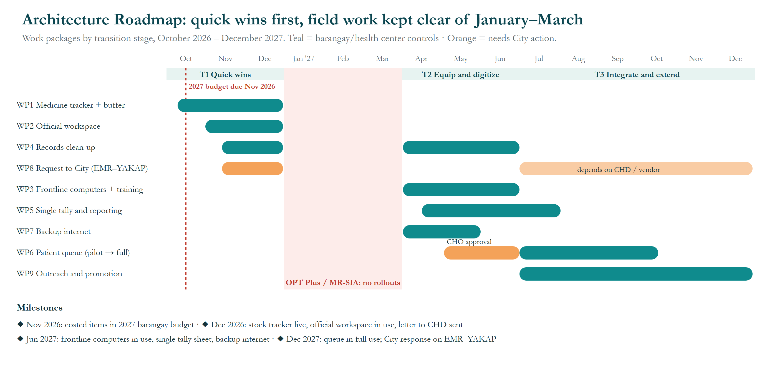
Figure 11. Architecture Roadmap.
What this shows: when each improvement (work packages WP1–WP9) happens between October 2026 and December 2027. Teal bars are things the barangay or health center controls; orange bars need City action. Nothing new is rolled out from January to March, when staff are busy with OPT Plus and MR-SIA field work. Why it matters: quick, low-cost wins come first, timed to the 2027 barangay budget due in November 2026.

Definition of Transition States
State | Period | Description
Baseline | October 2026 | As described in Phases B–D
T1 Quick wins | November–December 2026 | Stock tracker, official workspace, chart index started, City request letter sent, costed items proposed in the 2027 barangay budget (due November 2026)
Freeze | January–March 2027 | No changes during OPT Plus and MR-SIA
T2 Equip and digitize | April–June 2027 | Shared computers, single tally sheet, backup internet, queue pilot, inactive charts archived
T3 Integrate and extend (target) | July–December 2027 | Queue in full use, expanded condo outreach, City decision on EMR–YAKAP integration

Business Architecture for Each Transition State
State | Business change
T1 | Medicine buffer policy proposed; filing standard agreed
T2 | Aides and BHWs record tallies on a computer; queue pilot rules
T3 | Queue process standard; condo outreach partnerships

Data Architecture for Each Transition State
State | Data change
T1 | Stock data in a shared sheet; program files on official storage; chart index begun
T2 | Single tally source; inactive charts archived on the 7-year schedule
T3 | Prescription data shared with YAKAP if the City adopts

Application Architecture for Each Transition State
State | Application change
T1 | Barangay-owned workspace and work-only chats
T2 | Tally and report templates; queue pilot application
T3 | Queue in production; EMR–YAKAP and dental links (City)

Technology Architecture for Each Transition State
State | Technology change
T1 | No new hardware
T2 | 2–3 shared desktops; backup LTE or second line; queue ticket and display
T3 | BNS field laptop and weighing kit; City laptop replacement (City)

- Abbreviations
Abbreviations, acronyms and reference codes used in this document and its figures, in alphabetical order.
Abbreviation | Meaning
ADM | Architecture Development Method, the step-by-step method of the TOGAF Standard
AG-1 … | Application gap reference number (Phase C)
BG-1 … | Business gap reference number (Phase B)
BHW | Barangay Health Worker
BNS | Barangay Nutrition Scholar
BP | Blood pressure
BP-1 … | Business process reference number
Brgy | Barangay
CHD | City Health Department (Pasig City)
CHO | City Health Officer
DG-1 … | Data gap reference number (Phase C)
DOH | Department of Health
e-OPT | Electronic Operation Timbang Plus tool of the National Nutrition Council
eMed / eMED | Name of the City's electronic medical record system; “dental eMED” is its separate dental system
EMR | Electronic Medical Record
FHSIS | Field Health Services Information System (DOH)
FP | Family planning
G1 … G5 | Goal reference number
GAMOT | PhilHealth Guaranteed and Accessible Medications for Outpatient Treatment
GB | Gigabyte (a unit of file size)
HCI | Health Care Institution (PhilHealth portal for health facilities)
Hon. | Honorable (title of elected officials)
IPCR | Individual Performance Commitment and Review
IT | Information technology
ITIS | Integrated Tuberculosis Information System (DOH)
ITR | Individual Treatment Record (the patient's registration form)
LGU | Local Government Unit
LMIS | Logistics Management Information System
LTE | Long-Term Evolution (4G mobile internet)
MOU | Memorandum of Understanding
MR-SIA | Measles-Rubella Supplemental Immunization Activity
MWF | Monday, Wednesday and Friday
NCD | Non-communicable disease (e.g., hypertension, diabetes)
NGO | Non-government organization
NIP | National Immunization Program
NNC | National Nutrition Council
OPT / OPT Plus | Operation Timbang Plus: yearly weighing and measuring of children aged 0–59 months
PCGH | Pasig City General Hospital
PhilHealth | Philippine Health Insurance Corporation
PLDT | PLDT Inc., an internet and telephone provider
QR | Quick Response (a scannable square barcode)
RA | Republic Act (a Philippine law)
RMC | Rizal Medical Center
Rx | Prescription
SWMO | Solid Waste Management Office (City of Pasig)
T1 … T3 | Transition architecture stage
TB | Tuberculosis
TG-1 … | Technology gap reference number (Phase D)
TOGAF | The Open Group Architecture Framework (the TOGAF® Standard)
UA&P | University of Asia and the Pacific
UPSC | Unique Prescription Security Code
UV | Ultraviolet
WP1 … WP9 | Work package (a group of related changes delivered together)
YAKAP | PhilHealth Yaman ng Kalusugan Program (primary-care benefit)

